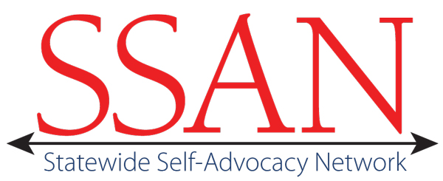
SSAN Regional Meeting- Southern California
October 4, 2012
10 AM to Noon
SSAN Members:
Area Board 10 Kecia Weller
Tarjan UCLA Steven Kapp

SSAN Organization Representatives:
USC UCEDD: Barbara Wheeler, Fran Goldfarb
USC UCEDD Member: Alison Liao (member host) was unavailable for meeting due to beginning college; Minah took notes to update Alison.
USC UCEDD Facilitator: Minah Kim (by AdobeConnect from So. Korea)
Area Board 10 Facilitator: Julie, Eby-McKenzie
Meeting Facilitator: Mark Starford
Tech Support/Training: Leslie Levine (by AdobeConnect)

Review purpose of regional meetings:
Kecia reported she originated the 1st regional meeting after SSAN April meeting as a way to share updates on plans and strategize for full SSAN meetings.

Network process:
Regions and organizations will develop advocacy plans over the next year.
BRC will fade as members and regions grow stronger
Members and regions become the leaders at all the meetings
- Each meeting demonstrates new strategies for members to take charge
- Use of technology links organizations, advocacy groups and members

Discussion about attendance at the regional meeting:
- Trena (AB 13) is in school
- Jesse (ARCA) Supported Life Conference date conflict

- Other invited members did give a reason. They were unavailable or did not respond to numerous emails and telephone messages from USC.

Recommendations:
  - Email members to get feedback on interest for future regional meetings
  - Create online survey to find best dates for everyone
- Kecia will contact Austin & Trena (Chair/Vice Chair) to see about having time at SSAN meeting 11/2012 for N/S members to meet.

Next Steps:
- Request that BRC set up an AdobeConnect call for Kecia W, Robert L, Steven K & Jimmy L to discuss their experiences as meeting hosts;
  - Outcome: Create a document to help future hosts; Steven will create list of SoCal issues to share on call

Member Sharing:
Steven is unavailable for November meeting; he will work with Leslie (Tech) to pre-record his report using AdobeConnect to ensure Tarjan is represented.
Planning: Steven created a sustainable plan & goals; has begun unstructured long and medium term work goals and narrowed his plan to include smaller outcomes; (1) Creating boundaries between work & personal life
(2) Seeking clarification about the role of facilitator and the unique situation he experiences where his support is also his employer.

Kecia continues work on her leadership plan in personal areas along with goals that support empowerment with agencies and employment. Kecia views herself as a peer advocate and role model with success and shares the individual steps taken to realize outcomes.

Discussion
There is Interest in there being an available document for members that describes different types of facilitators and what they can do to support people. Examples of type of facilitators include natural (friends, family), paid, organization provided, etc.

Meeting adjourned – 12.15 PM

